Pods and Services in Kubernetes Deployment

Work with pods, services:

Create a pod: kubectl run my-pod --image=nginx --namespace=k8-space

Get pods: kubectl get pods --namespace=k8-space

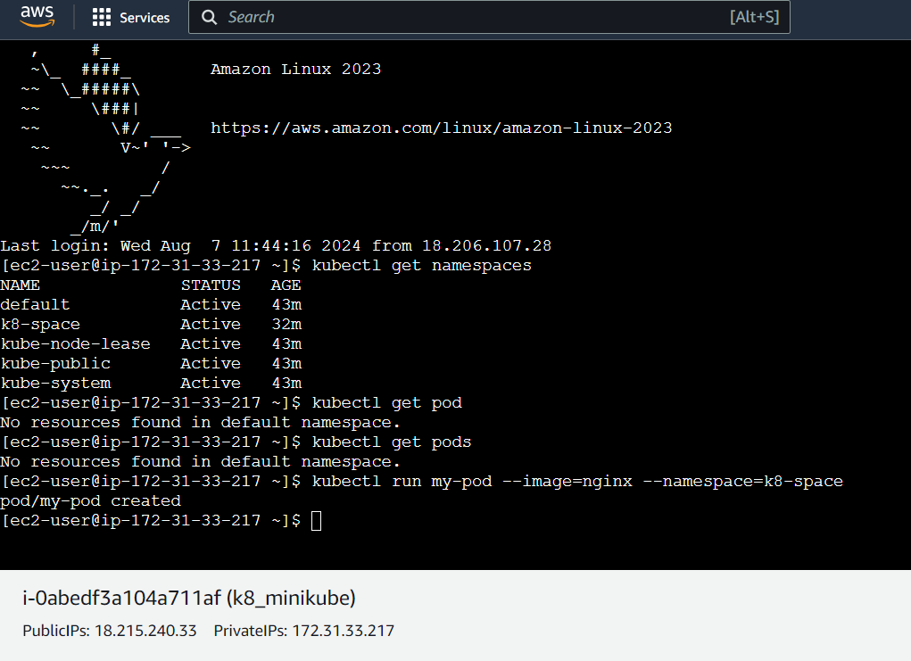

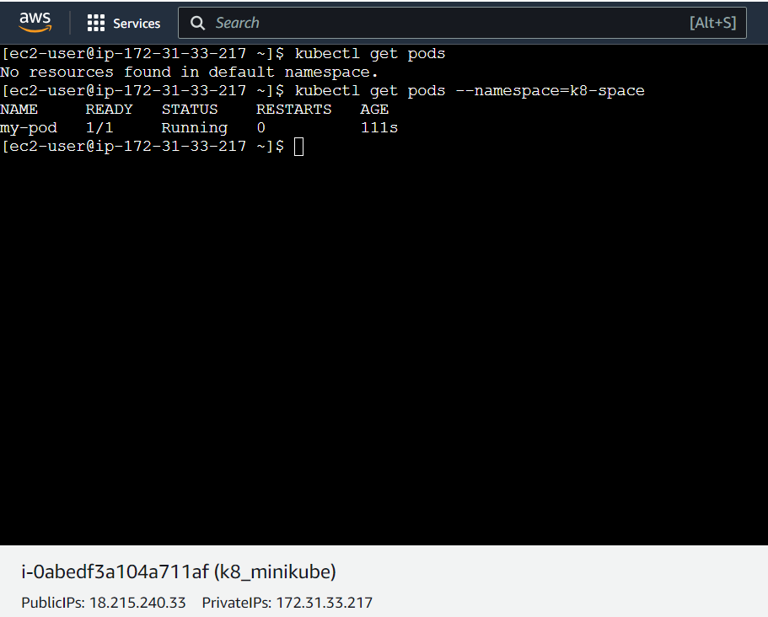

To get detail description of any pod

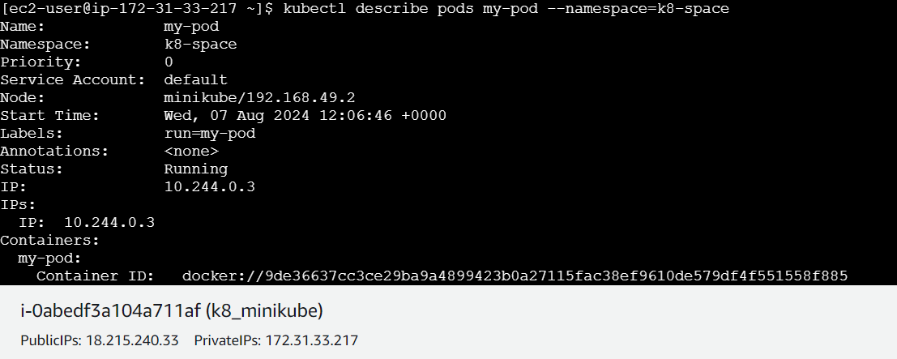

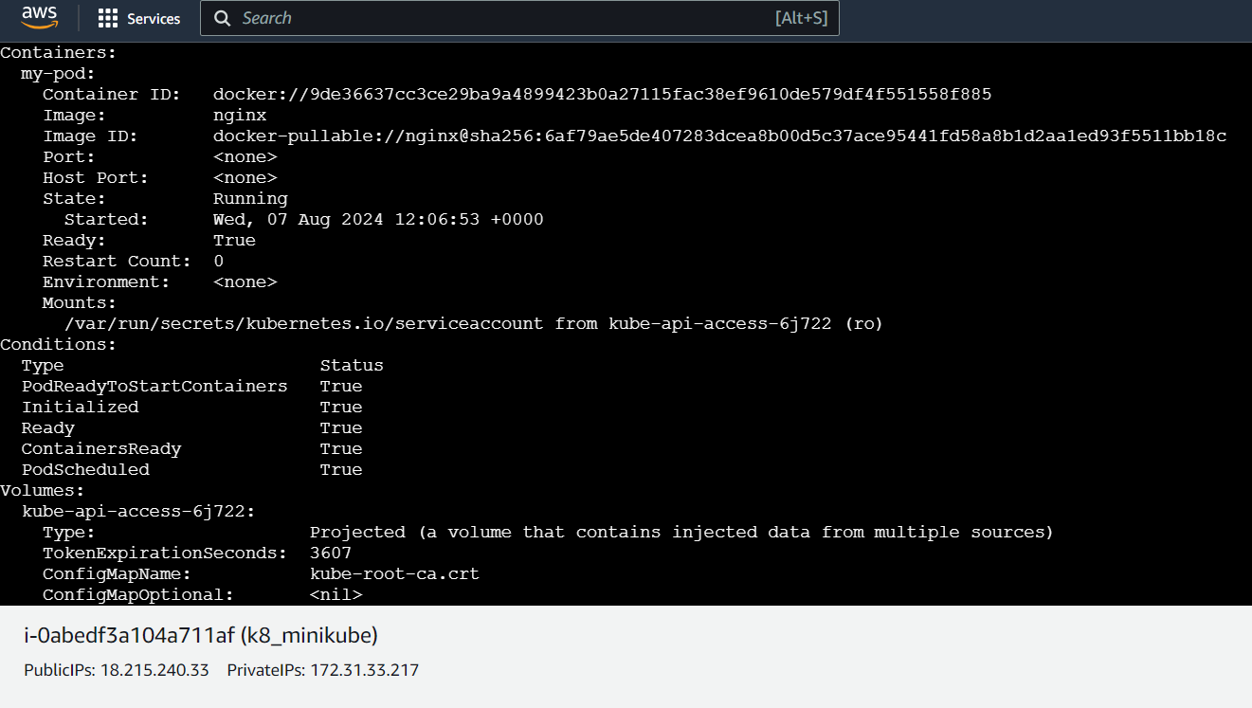

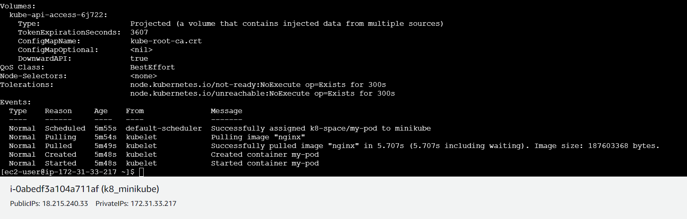

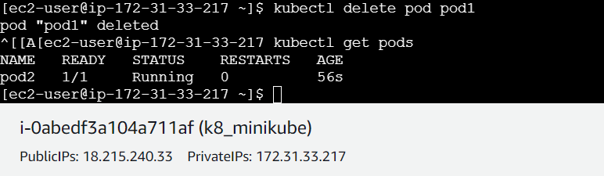

4. Create a service: kubectl expose pod pod2 --type=NodePort --port=80

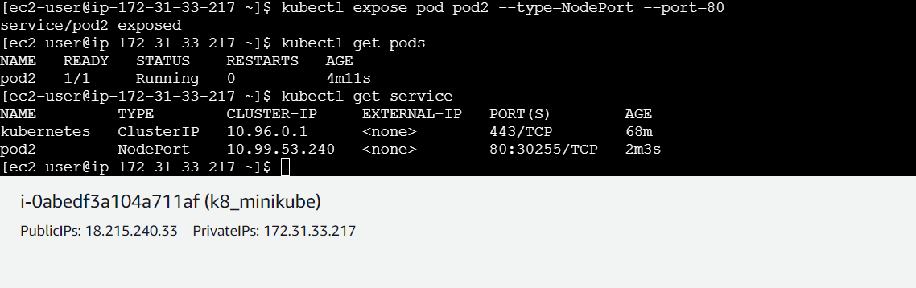

Create a NodePort service for the pod named pod2



5. Get services: kubectl get svc --namespace=k8-space

Deployment:

1. Create a deployment: kubectl create deployment my-deply --image=nginx

--replicas=3

2. Get deployments: kubectl get deployments

3. Scale deployment: kubectl scale deployment my-deply --replicas=5

4. Update deployment image:

kubectl set image deployment/my-deply nginx=nginx:latest

5. Delete deployment: kubectl delete deployment my-deply

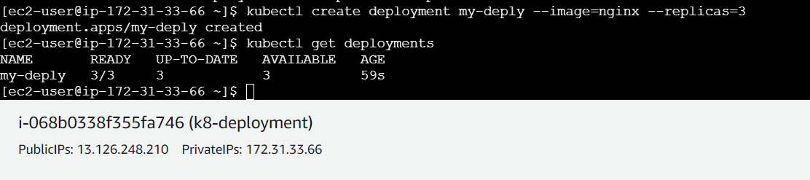

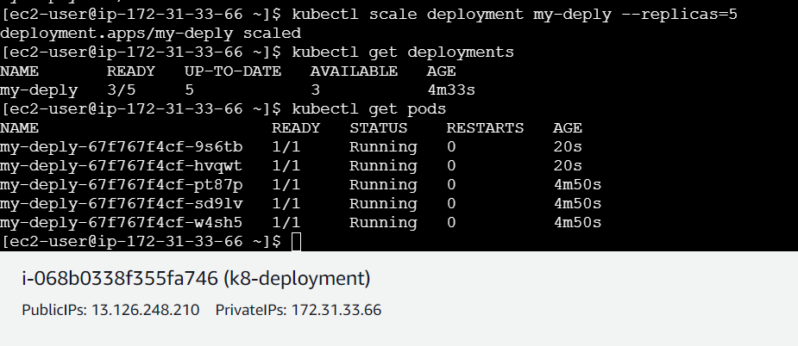

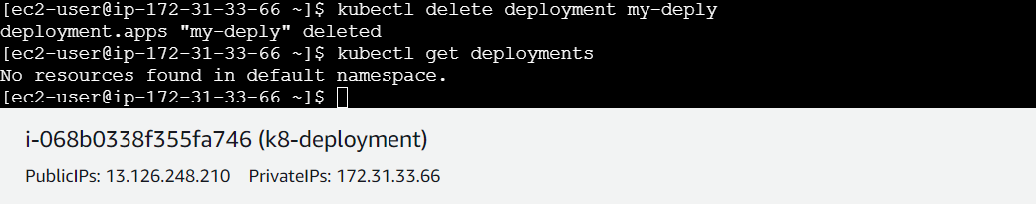

To run a Deployment via a manifest file, follow these steps:

1. Create a YAML file (e.g., nginx-deployment.yml) with the Deployment configuration.

2. Use kubectl apply to apply the configuration:

**kubectl apply -f nginx-deployment.yml**

This command creates the Deployment and its associated resources.

Alternatively, you can use kubectl create to create the Deployment:

**kubectl create -f nginx-deployment.yml**

Note: kubectl create will fail if the resource already exists, whereas kubectl apply will update the existing resource.

This nginx-deployment.yml file defines:

1. A Deployment named "nginx-deployment" with 3 replicas.

2. Pods running the latest Nginx image, exposing port 80.

3. A Service named "nginx-service" that selects the Pods and exposes port 80, with a ClusterIP.

With type: ClusterIP, the Service will expose the Pods on a cluster-internal IP address, making it accessible only within the cluster. You can access the Nginx service by visiting http://<cluster-ip>:80.



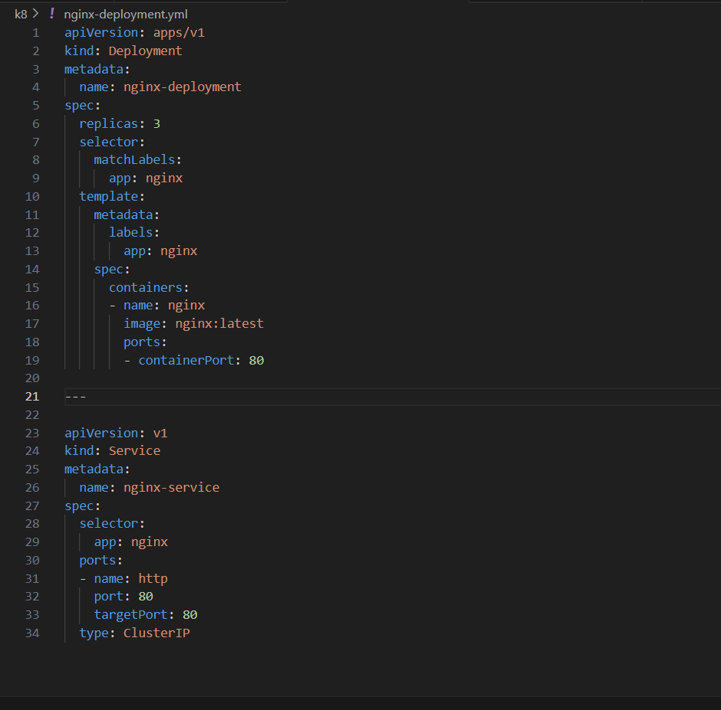

Note the **---** separator between the Deployment and Service definitions. This is required to separate multiple resources in a single manifest file.

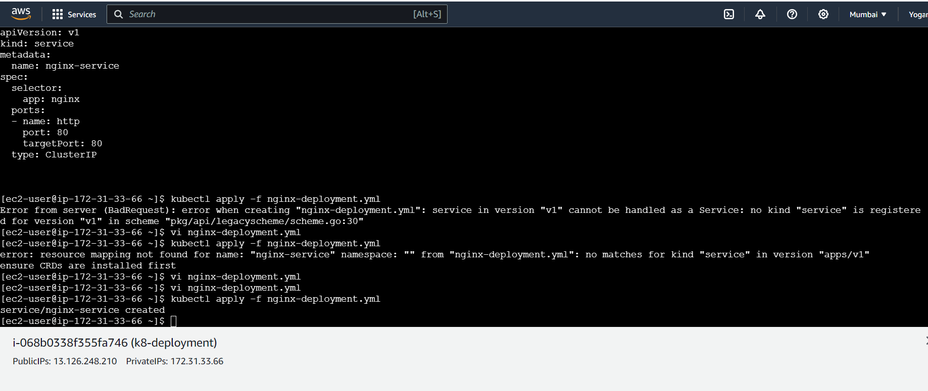

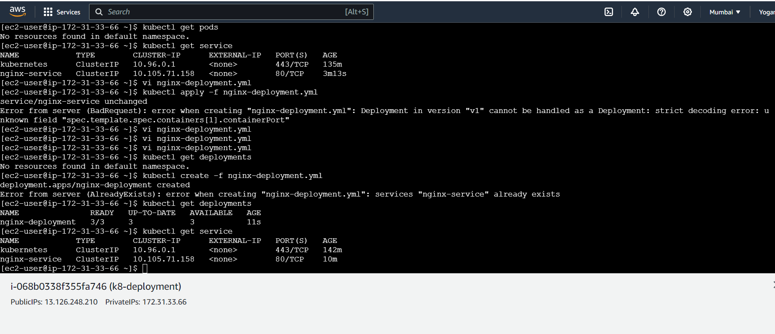

Delete deployment:

